The Automatic DebugRobot software is worth gold
for EMS providers like Surface Art Engineering

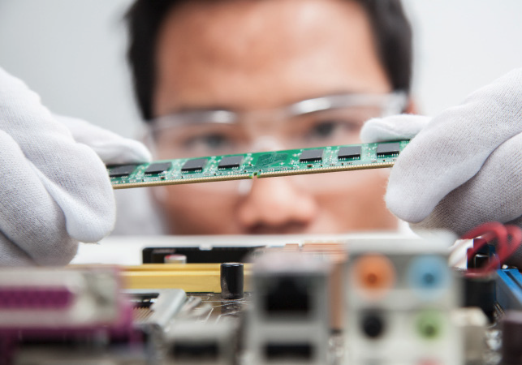

With the DebugRobot, Digitaltest has developed a procedure that can automatically debug test programs. This means that up to 80 % of the device under test can now
be covered automatically, so that only a few critical measurements have to be checked manually afterwards.

The Automatic DebugRobot was originally developed at the request of an EMS service provider, Surface Art Engineering, which operates as a central point of contact for
simplifying the process of launching products to the market.

The challenge was to speed up the long debugging times for boards with more than
500 nets by developing an automated test program to enable Surface Art Engineering
and its customers to get to market faster.

For a board with 1,000 nets, an engineer previously needed two weeks, but with the DebugRobot six boards can now be debugged in a two-week period! This not only
saves valuable time, but also helps to automatically stabilise measurements i.e. to achieve the lowest possible standard deviation of the values when repeating measurements.

With the help of the DebugRobot, Surface Art Engineering not only saved time and money, but also maximized test quality. All of this contributed to both faster processing of orders and a significant reduction in the time to market of a product. This, together with automatic error correction, is often a decisive factor, especially for EMS service providers.

The DebugRobot is part of the current CITE 8 software from Digitaltest.

About Digitaltest

As a leading partner in the electronics industry, Digitaltest develops and produces
automated test equipment (ATE) for electronic circuit boards, software for automating production, and quality management systems. Digitaltest is known for innovative
solutions for optimizing the entire manufacturing process – as an interface between
CAD, the testing process and production itself. We also offer comprehensive service
and support, including complete outsourcing of PCB testing at locations worldwide.

40 years of cutting-edge technology, reliability, and value retention in automated test systems.

Sarah Boctor-Vauvert
CEO
E-Mail: sarah.boctor-vauvert@digitaltest.de
Telefon: +49 (7244) 96 40 -24
Digitaltest GmbH
Lorenzstr. 3
76297 Stutensee

www.digitaltest.com

