Powerful Performance with CITE 8
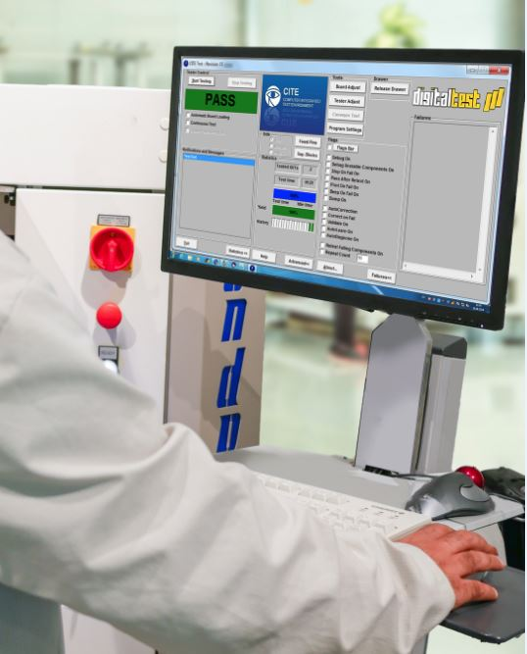

CITE 8 is equipped with the latest intelligence -
More power in less time

With the latest Digitaltest test system software CITE 8, test programs for complex PCBs can be generated and even debugged - without human intervention.

Create test programs for complex PCBs at the push of a button

With the new, intelligent Automatic Program Generator 2.0 (APG), test programs can now be created automatically. All you need is the assembly description (CAD, BOM) and the program generates itself with a mouse click. With APG 2.0, even complex electronic assemblies can be handled easily. Components are often not completely contactable and when interconnecting basic components such as R, L, C, D, Z it is therefore necessary to use so-called Cluster tests for In-circuit and Functional tests. Even this the APG 2.0 handles completely autonomously, because it can group components together as a unit and independently determines the test sequence for a Cluster test.

Such serial and parallel combinations increase the test coverage and are already integrated in APG 2.0. No user has to invest time and effort to manually generate complicated series and parallel tests anymore. The new APG 2.0 handles this automatically.

Another significant modification is the version handling, that now allows APG 2.0 to check and compare both, basic and additional versions of the same board. It now runs once per version and generates a compact result.

Test programs can be debugged automatically

The new CITE 8 Module: Debug Robot is an intelligent program, that can debug a test program virtually autonomous. All the user needs to do is adjust the settings in the template according to his specifications.
The DebugRobot can then debug the test program by itself. Especially for boards with many test points this is an enormously complex and lengthy process with potential for errors if done manually. With the DebugRobot this process runs fully automated. This not only saves the cost of valuable working time, but also speed up the process of new product introduction (NPI) or technical changes. In some cases, there might be only a few critical measurements, which must be processed manually after debugging is complete.

CITE 8 equipped with limited Windows rights

With this new CITE module two levels of Windows users can be created. One with administration rights and one for standard users. With the option "Admin Credentials" the access rights are defined in advance by a Windows administrator in the user administration and savely encrypted.
This prevents unwanted changes to the test program by a standard user.

New: Support of Visual Studio up to version 2019

The CITE software platform uses Microsoft's development environment Visual Studio as the programming language for the test programs. From now on support is also possible up to version 2019. Additionally, CITE 8 is available for Windows 10 with 32/62 Bit.

About Digitaltest

As a leading partner in the electronics industry, Digitaltest develops and produces
automated test equipment (ATE) for electronic circuit boards, software for automating production, and quality management systems. Digitaltest is known for innovative
solutions for optimizing the entire manufacturing process – as an interface between
CAD, the testing process and production itself. We also offer comprehensive service
and support, including complete outsourcing of PCB testing at locations worldwide.

40 years of cutting-edge technology, reliability, and value retention in automated test systems.

Sarah Boctor-Vauvert
CEO
E-Mail: sarah.boctor-vauvert@digitaltest.de
Telefon: +49 (7244) 96 40 -24
Digitaltest GmbH
Lorenzstr. 3
76297 Stutensee

www.digitaltest.com

