Digitaltest consistently extends its international
sales network

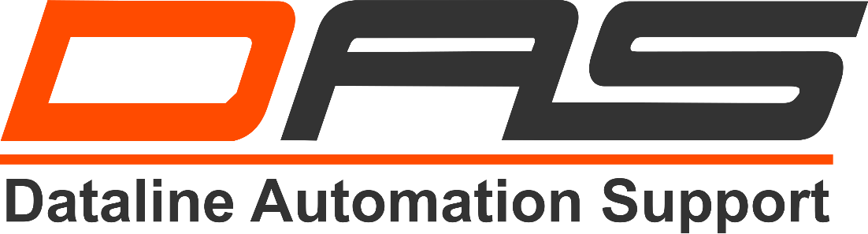

As part of the expansion of its international distribution network Digitaltest could acquire Dataline Automation Support (DAS) as new sales partner for Poland.

"With Dataline Automation Support we have a reliable local partner at our side to be able
to satisfy the increasing demands of the rapidly growing electronics market in Poland. As an established supplier of production equipment in electronics production facilities, Dataline Automation Support has extensive knowledge and good contacts to the industry," says Hans Baka, Managing Director of Digitaltest.

The Dataline Automation Support (DAS) was founded in 2005 and specializes in the procurement and provision of technically high-quality equipment for the entire electronics industry in Poland. Due to their excellent sales network and many good contacts they are able to offer comprehensive solutions of the highest quality.

About Digitaltest

As a leading partner in the electronics industry, Digitaltest develops and produces
automated test equipment (ATE) for electronic circuit boards, software for automating production, and quality management systems. Digitaltest is known for innovative
solutions for optimizing the entire manufacturing process – as an interface between
CAD, the testing process and production itself. We also offer comprehensive service
and support, including complete outsourcing of PCB testing at locations worldwide.

40 years of cutting-edge technology, reliability, and value retention in automated test systems.

Sarah Boctor-Vauvert
CEO
E-Mail: sarah.boctor-vauvert@digitaltest.de
Telefon: +49 (7244) 96 40 -24
Digitaltest GmbH
Lorenzstr. 3
76297 Stutensee

www.digitaltest.com

