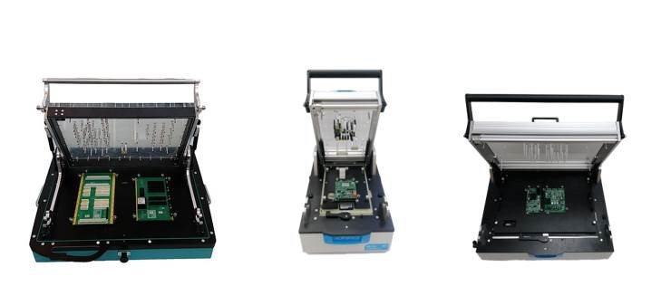

New Digitaltest fixture house

Due to the general increase in demand for applications and the associated supply bottlenecks at world-renowned fixture houses, Digitaltest has decided to offer its
own fixture service.

"With the development of an in-house fixture service, we see an opportunity to significantly reduce the long waiting times for the construction of fixture devices for our customers and ourselves", said Sarah Boctor-Vauvert, CEO of Digitaltest. In order to remain flexible and to be able to react quickly to customer requests, the installation of the the machine park in Cairo was extended with a new CNC milling machine. This machine is intended to strengthen the diverse production possibilities and ensure short production routes within the company.

In the past, Digitaltest has already gained experience in fixture construction in its in-house testing and repair department, for example for the Eagle MTS 180 pneumatic and the Sigma MTS 300 vacuum fixture. Also for internal benchmarks and external projects customized Condor Flying Probe fixtures were prepared. "The latest technology is our two-stage device with a lifting mechanism for the Condor Flying Probe, which allows the board to be contacted in two different steps with different needle heights and thus, for example ICT test and programming can be made together," says Sarah Boctor-Vauvert.

In addition to fixtures, Digitaltest can produce customized PCB carriers with an irregular shape or edge of less than 3 mm. The latest development consists of a Condor Flying Probe universal PCB carrier, the so-called Universal PCB Carrier, which can be used for all printed circuit boards.

The Digitaltest In-house fixture Service offers:

- Precision through professional, mechanical design and machining tools
with a high precision level of 20 µm.
- Excellent engineering with experienced mechatronics engineers, who have had extensive training on the milling machine in cooperation with a university work-study program.
- Checking the fixture design in advance with the customer.
- PCB analysis with test reports for tension and strain analysis ensure PCB safety
and accurate test stability.
- Transparency in the form of complete documentation and parts list reports,
which can be referred to in case of future changes to the board layout.
- Quality assurance with prior testing of the fixture on the appropriate Digitaltest system. This is a main advantage to other fixtures houses.

The fixture capabilities at Digitaltest Egypt include:

- Sigma Vacuum fixture
- Sparrow Mechanical fixtures
- Eagle Pneumatic Press fixture
- Condor fixtures
- Multi Level Fixture (incl. Condor: fixture lifting mechanism)
- Condor PCB carrier
- Universal PCB carrier
Additional fixture features:
- Pneumatics
- FEASA (LED Analyzing)
- Relay Boards
- Barcode Scanners
- Manual push rods
- Special pushes
- push plate
- top probing
- side probing

Read more on www.digitaltest.com

About Digitaltest

As a leading partner in the electronics industry, Digitaltest develops and produces automated test equipment (ATE) for electronic circuit boards, software for automating production, and quality management systems. Digitaltest is known for innovative solutions for optimizing the entire manufacturing process – as an interface between CAD, the testing process and production itself. We also offer comprehensive service and support, including complete outsourcing of PCB testing at locations worldwide.
40 years of cutting-edge technology, reliability, and value retention in automated test systems.
Sarah Boctor-Vauvert
CEO
E-Mail: sarah.boctor-vauvert@digitaltest.de
Telefon: +49 (7244) 96 40 -24
Digitaltest GmbH
Lorenzstr. 3
76297 Stutensee

www.digitaltest.com

