Avoid supply chain disruption - with the
right test system from Digitaltest!

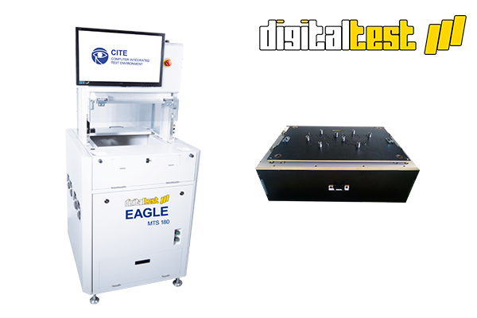

The cost-effective Eagle test system from Digitaltest is particularly suitable for
setting up a short-term production line. This system is currently available with
a special discount.

The Eagle MTS 180 is the most economical solution for high volume production. It can
be used for a high volume of electronic PCBs as well as for many different types of assemblies. With its 1.000 measurements per second, it is also one of the fastest test systems on the market.

The In-Circuit tester can test up to 3.456 pins and is equipped with a pneumatic press,
which also enables the testing of mechanical fixtures. These fixtures can also be built
cost-effectively by Digitaltest and can be designed for both double-sided and small pads.
The production of expensive vacuum fixtures is therefore not necessary.

The Eagle MTS 180 test system and the mechanical fixtures are available at short term. Digitaltest is currently offering a special COVID-19-discount on this system, which makes
it particularly attractive. For further information please contact sales@digitaltest.com

About Digitaltest

As a leading partner in the electronics industry, Digitaltest develops and produces
automated test equipment (ATE) for electronic circuit boards, software for automating production, and quality management systems. Digitaltest is known for innovative
solutions for optimizing the entire manufacturing process – as an interface between
CAD, the testing process and production itself. We also offer comprehensive service
and support, including complete outsourcing of PCB testing at locations worldwide.

40 years of cutting-edge technology, reliability, and value retention in automated test systems.

Sarah Boctor-Vauvert
CEO
E-Mail: sarah.boctor-vauvert@digitaltest.de
Telefon: +49 (7244) 96 40 -24
Digitaltest GmbH
Lorenzstr. 3
76297 Stutensee

www.digitaltest.com

