With MicroVision Technologies also optimally positioned in Eastern Europe
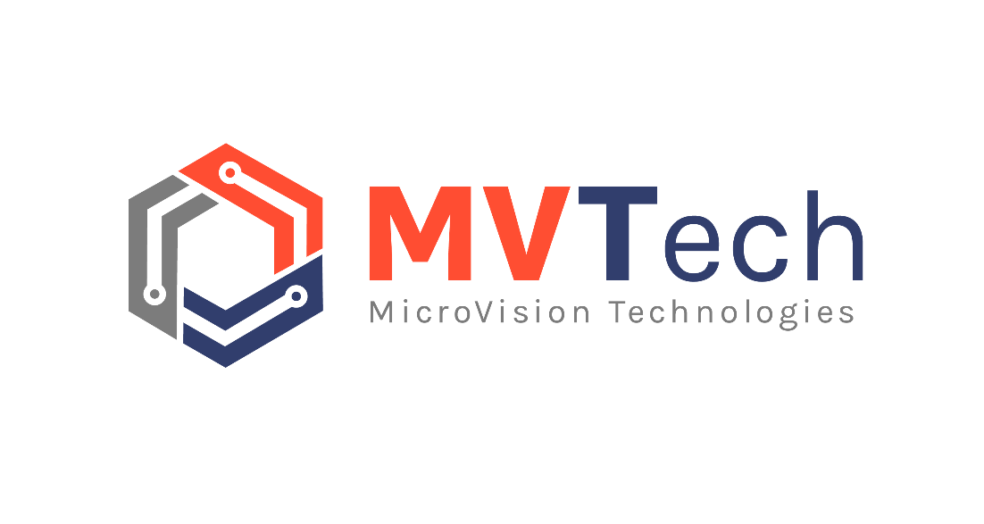

Digitaltest has a new partner: The Romanian company MicroVision Technologies (MVTech) is immediately as new Distributor responsible for the country axis Romania, Bulgaria, Serbia, Croatia and Bosnia.

"We look forward to co-operation and are convinced that we will contribute with our know-how and our flexibility to be able to strengthen and develop the brand Digitaltest in this part of Europe further“, so MVTech managing director Gheorghe Rebegel.

This is MVTech
MVTech is one of the leading suppliers of high-quality technical equipment, consumables and services for the electronics industry in Eastern Europe. To their achievement portfolio belong not only first-class products, but also service and application support. The company
is located in the southwest of Romania and has more than 15 years of experience in SMT production.

Two companies - one passion
Hans Baka, managing director of Digitaltest, is also looking forward to the cooperation:
"We have found a trustworthy partner who is a perfect match for us. Like Digitaltest also MVTech has very experienced employees, who are driven by motivation and daily new challenges. With their competence and application expertise we will complement each other perfectly and can thus offer our joint customers the best possible support. Us both connects thereby the boundless passion for electronic products.”

About Digitaltest

As a leading partner in the electronics industry, Digitaltest develops and produces
automated test equipment (ATE) for electronic circuit boards, software for automating production, and quality management systems. Digitaltest is known for innovative
solutions for optimizing the entire manufacturing process – as an interface between
CAD, the testing process and production itself. We also offer comprehensive service
and support, including complete outsourcing of PCB testing at locations worldwide.

40 years of cutting-edge technology, reliability, and value retention in automated test systems.

Sarah Boctor-Vauvert
CEO
E-Mail: sarah.boctor-vauvert@digitaltest.de
Telefon: +49 (7244) 96 40 -24
Digitaltest GmbH
Lorenzstr. 3
76297 Stutensee

www.digitaltest.com

