Digitaltest integrates FlashRunner from SMH Technologies into
their Flying Probe Tester
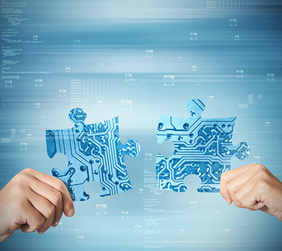

Innovation in the field of automated test systems meets the most
advanced ISP programming solutions – the basis for the two companies Digitaltest and SMH Technologies to work together in partnership
and realise joint projects from now on.

Digitaltest, one of the leading suppliers of electronic test systems, has been successfully using the FlashRunner series from SMH Technologies for its
in-circuit test applications for many years. The FlashRunner 2.0 from SMH is
the result of decades of experience and the most advanced technology in the
field of In-system programming (ISP), which makes it possible to program up
to 16 different components simultaneously.

Due to its flexibility, it is particularly suitable for programming multi-PCB panels
and complex boards, which can be programmed on Digitaltest systems completely independently of each other and -through the Digitaltest Lambda Edition- also
tested in parallel.

Until now, the FlashRunner was only used for in-circuit testing, but now
flash programming is also possible with the Condor Flying Probe from Digitaltest. Four movable test heads, the Flying Probes, can be directly programmed and autonomously controlled from above. An additional fixture from below is no longer necessary. This not only saves the costs of manufacturing the fixtures, but also
the construction times that are necessarily associated with them are a thing of
the past. Moreover, since there are no additional loads due to fixtures and wiring, stable measurements are guaranteed.

The Power Programmer still has an extensive library at its disposal, which means that it can handle most programmable circuits.

The FlashRunner 2.0 from SMH Technologies is thus ideally suited for integration into Digitaltest's Condor Flying Probe and offers another way to improve quality
while saving time.

About Digitaltest

As a leading partner in the electronics industry, Digitaltest develops and produces
automated test equipment (ATE) for electronic circuit boards, software for automating production, and quality management systems. Digitaltest is known for innovative
solutions for optimizing the entire manufacturing process – as an interface between
CAD, the testing process and production itself. We also offer comprehensive service
and support, including complete outsourcing of PCB testing at locations worldwide.

40 years of cutting-edge technology, reliability, and value retention in automated test systems.

Sarah Boctor-Vauvert
CEO
E-Mail: sarah.boctor-vauvert@digitaltest.de
Telefon: +49 (7244) 96 40 -24
Digitaltest GmbH
Lorenzstr. 3
76297 Stutensee

www.digitaltest.com

