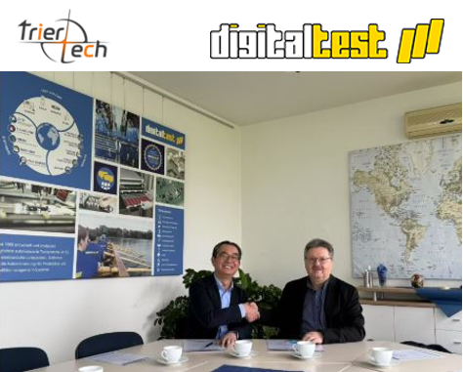

Digitaltest Announces Triertech as New Sales Distributor in China
With over 45 years of experience, Digitaltest is renowned for its technological leadership, reliability, and value. The company’s solutions streamline manufacturing by seamlessly connecting design, testing, and production, ensuring high-quality outcomes for electronic circuit boards. Digitaltest also offers comprehensive global service, support, and outsourced PCB testing, making it a trusted partner for electronics manufacturers worldwide.

“We are excited to partner with Triertech Co Ltd to expand our reach in China and Asia” said Hans Baka, CEO of Digitaltest GmbH. “Triertech’s expertise in test and inspection solutions aligns perfectly with our mission to deliver state-of-the-art ATE systems and support to electronic manufacturers. This partnership will enable us to better serve our customers in this dynamic and growing market.”

Triertech Co Ltd brings extensive industry knowledge and a strong network to the partnership, positioning it to effectively distribute and support Digitaltest’s portfolio of solutions. By combining Triertech’s regional expertise with Digitaltest’s innovative technology, the collaboration promises to deliver unparalleled value to customers seeking to enhance their manufacturing processes.

For more information about Digitaltest’s solutions or to connect with Triertech Co Ltd, visit www.digitaltest.com.

About Digitaltest

As a leading partner in the electronics industry, Digitaltest develops and produces
automated test equipment (ATE) for electronic circuit boards, software for automating production, and quality management systems. Digitaltest is known for innovative
solutions for optimizing the entire manufacturing process – as an interface between
CAD, the testing process and production itself. We also offer comprehensive service
and support, including complete outsourcing of PCB testing at locations worldwide.

More than 45 years of cutting-edge technology, reliability, and value retention in automated test systems.

