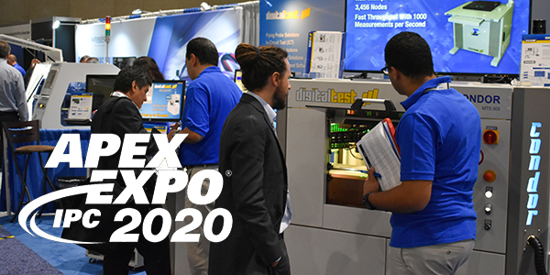

APEX 2020: Digitaltest equips for the future
As one of the leading providers of flying probe, in-circuit, functional test and production software solutions, Digitaltest is presenting test solutions for electronics manufacturers at IPC APEX EXPO in San Diego, California. The fair will take place from 4 to 6 February
2020, Digitaltest has the booth 636.

Among other things, the experts there will show how existing fixtures and test programs can simply be continued to be used by using a hardware converter, what advantages the new Digitaltest fixture service has and why the Condor Flying Probe can be used universally for all test strategies. In addition, the easily scalable parallel testing concept will be presented, which shortens cycle times and increases throughput.

Switch to Digitaltest - without fixture costs and program conversion effort

Because they have a pure 1:1 pin architecture (no multiplexing of pins), Digitaltest test systems are the most flexible on the market. This allows easy and fast fixture design as well as fixture and test program conversion from old systems. Digitaltest demonstrates how existing fixtures and test programs can be easily continued to be used on new systems with the help of a hardware converter.

Digitaltest fixture without long waiting times

Due to the general increase in demand and the associated supply bottlenecks at fixture houses, Digitaltest has expanded its own fixture service. Highly qualified and experienced mechatronics engineers are providing a high level of precision of 20 µm with the latest available mechanical and machining tools. Digitaltest checks the fixture design, makes a PCB analysis and each fixture is tested on the corresponding Digitaltest system before delivery. The high quality fixtures are produced with fixture kits from renowned fixture manufacturers, which you can see at the booth at the Apex.

Universal Flying Prober with higher test coverage

The Condor Flying Probe can be used universally for all test strategies: both in series production as well as in-line system, for testing prototypes in small series with manual loading or for functional tests. It offers a test platform that can map all tests, from simple
in-circuit tests and functional tests to BoundaryScan and PowerUp, on one system. With
its "one-stop" test strategy, all tests in production can therefore be tested at single test station. Through a suitable fixture concept from Digitaltest, both test depth and throughput can be increased. This results in a much higher error coverage - and all without additional costs for equipment, production area and staff.
At Apex, Digitaltest will also be demonstrating how the new LED tests with colour recognition and light intensity work on the Condor Flying Probe.

Parallel testing for faster handling of test tasks

With the Digitaltest Sparrow MTS 30 Lambda edition, cycle times can be shortened easily, and throughput increased. This improvement in productivity can be achieved by testing two different PCBs at the same time. The parallel testing concept can also be implemented with several boards and can also be implemented with all Digitaltest ICT test systems with the Lambda edition. An ICT or function test is carried out by two or more independent test heads, thereby reducing the test time by the corresponding factor. This applies to panels as well as to several independent individual boards.

Visit the test experts from Digitaltest at booth 636 and find out more about the various test options, repair solutions and test service.

IPC APEX EXPO 2020
4th - 6th of February 2020
San Diego, Convention Center
California, USA
Digitaltest booth 636

About Digitaltest

As a leading partner in the electronics industry, Digitaltest develops and produces
automated test equipment (ATE) for electronic circuit boards, software for automating production, and quality management systems. Digitaltest is known for innovative
solutions for optimizing the entire manufacturing process – as an interface between
CAD, the testing process and production itself. We also offer comprehensive service
and support, including complete outsourcing of PCB testing at locations worldwide.

40 years of cutting-edge technology, reliability, and value retention in automated test systems.

For more information contact:

Sarah Boctor-Vauvert
CEO
E-Mail: sboctor-vauvert@digitaltest.net
Telefon: +1 (925) 603 - 8650

Digitaltest Inc.
5046 Commercial Circle, Suite C
Concord, CA 94520
USA

www.digitaltest.com

