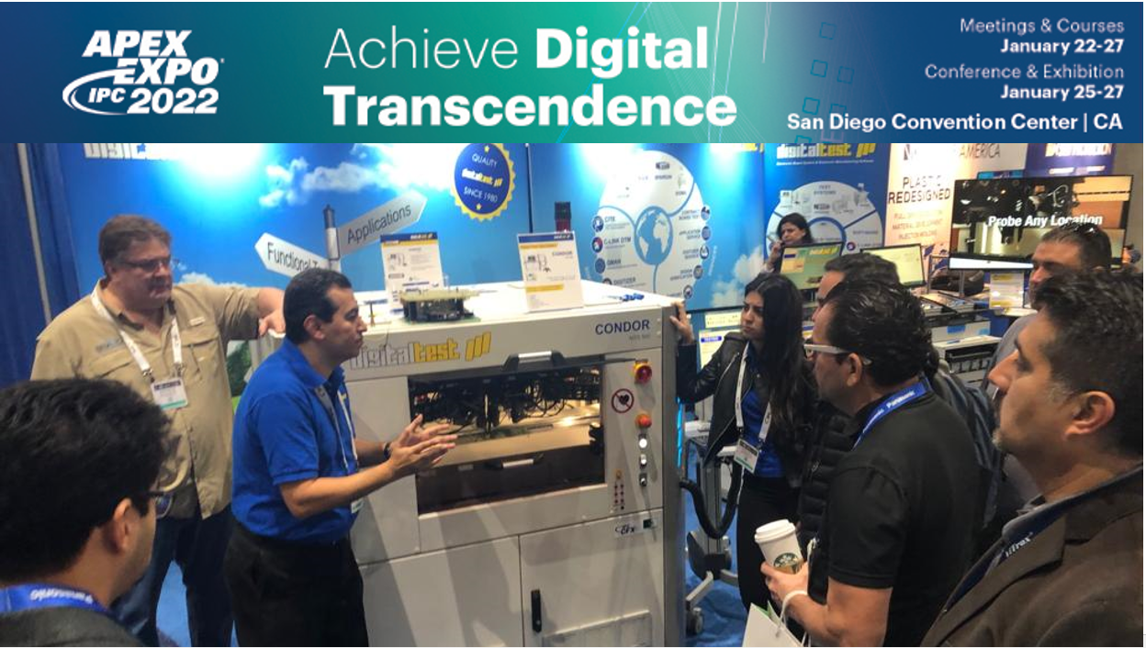

APEX 2022: Digitaltest joins forces
As one of the leading providers of flying probe, in-circuit, functional test, and production software solutions, Digitaltest is presenting test solutions for electronics manufacturers at booth #725, IPC APEX EXPO in San Diego, California on 25-27 January 2022.

This year Digitaltest will join forces with ATX Hardware, providing high end fixture solutions and JOT Automation for a new inline concept.

Our experts present you our newest technologies and developments of testing equipment. We will demonstrate you, why our flying probe is the most advanced and reliable in the market and how it can help you to overcome high cost of constant layout changes due to obsolescence of components with our new concept: Eco on the Fly. Find out why Digitaltest joins force with ATX Hardware and JOT Automation.

Condor Flying Prober now with 64-bit technology

The newest Condor Flying Probe is now using 64-bit technology, which means it is compatible with the newest technology on the market. The color camera of the Condor Flying probe has new features such as barcode scanner and optical character recognition (OCR). and our flying probe can be used universally for all test strategies: both in series production as well as in-line system, for testing prototypes in small series with manual loading or for functional tests. It offers a test platform that can map all tests, from simple in circuit tests and functional tests to Boundary Scan, Power Up and Flash Programming in one single system. With its one-stop test strategy, all tests in production can therefore be tested at single test station. Through a suitable fixture concept from Digitaltest, both test depth and throughput can be increased. This results in a much higher test coverage - and all without additional costs for equipment, production area and staff.

Eco on the Fly: Dealing with PCB layout changes while saving old fixtures

Digitaltest introduces ECO on the Fly, a new concept on how to continue testing boards during times of supply chain interruptions and necessary board design changes caused by obsolescence of components. With ECO on the Fly, Digitaltest has developed a procedure that combines the bed of nail test with the flying probe test and in which C-LINK, the CAD/CAM software, works out the delta of the two layout BOM variants. With the data generated, the fixtures and programs can be modified and, as before, the boards can be tested on the bed of nail test systems and now only the delta still needs to be tested on a Condor Flying Probe.

Digitaltest joins forces with ATX Hardware

Digitaltest works closely with its long-term partner ATX Hardware which provides high end fixture solutions. Digitaltest produces fixtures in their own fixture house, often using ATX hardware and fixture kits. For highly complex and special fixtures we work directly with ATX Hardware. ATX is Europe's market leader in the manufacture of test fixtures for electronic test procedures. As a specialized solution provider, the company designs and produces customer-specific products in semi-automated individual and small series production. Most of the devices are precision-engineered one-offs with varying degrees of complexity. At our booth the newest fixtures will be displayed on our test systems and ATX experts are ready to show you their different technologies they are using.

New, flexible Inline Concept- JOT-DT M5 Sparrow Inline

Visit our booth and check out our new flexible inline concept that we have created together with JOT Automation. A new affordable inline concept that not only saves space and time but also covers all different test: In-circuit test, functional test, programming etc. and this in parallel, guarantees highest flexibility and throughput. Our experts from JOT will be glad to give you a demonstration of the system and how it works.
Visit the test experts from Digitaltest at booth # 725 and find out more about the various test options, repair solutions and test service.

IPC APEX EXPO 2022
25th - 27th of January 2022
San Diego, Convention Center
California, USA
Digitaltest booth #725

About Digitaltest

As a leading partner in the electronics industry, Digitaltest develops and produces
automated test equipment (ATE) for electronic circuit boards, software for automating production, and quality management systems. Digitaltest is known for innovative
solutions for optimizing the entire manufacturing process – as an interface between
CAD, the testing process and production itself. We also offer comprehensive service
and support, including complete outsourcing of PCB testing at locations worldwide.

More than 40 years of cutting-edge technology, reliability, and value retention in automated test systems.

For more information contact:

Sarah Boctor-Vauvert
CEO
E-Mail: sboctor-vauvert@digitaltest.net
Telefon: +1 (925) 603 - 8650

Digitaltest Inc.
187 Contractors Street
Livermore, CA 94551
USA

www.digitaltest.com

