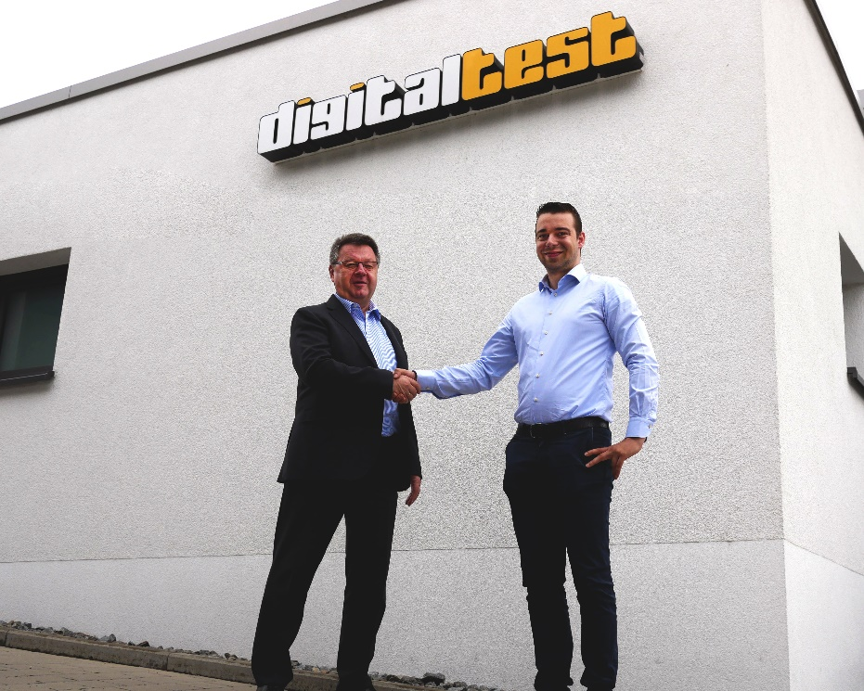

Common goals: Hans Baka (Digitaltest) with Geoffrey Raetsen (C.N. Rood)

**C.N. Rood becomes the new distributor for Digitaltest**

**in Scandinavia**

**The partnership has expanded: After the Benelux countries the Dutch company**

**C.N. Rood also takes over distribution for Digitaltest in Scandinavia.**

**A portrait of the new partner**

Since its foundation in 1938 C.N. Rood has grown to become the largest independent supplier for test and measurement instruments in the Benelux countries and now is

also operating very successfully in Sweden, Denmark and Norway.

Its wide range of solutions goes up from communications, video/CATV-test equipment

and test/measurement equipment in general to products for automatic identification. Consulting, training and turnkey solutions complete their portfolio.

**Geoffrey Raetsen, Account Manager at C.N. Rood is looking forward to expand**

**the cooperation**

“We didn't have to think long when Digitaltest approached us with the desire to

expand the existing work collaboration. This also demonstrates the good work we

have been doing so far and gives us the opportunity to grow further with Digitaltest

as a strong partner at our side.”

**Hans Baka, Managing Director/CEO of Digitaltest GmbH also looks optimistically**

**to the future**

"We have already had very good experiences with C.N. Rood in the Netherlands, Belgium and Luxembourg and have been in good partnership with the company. We are convinced that we will now be able to expand our successful work cooperation for the Scandinavian region as well.”

**About Digitaltest**

As a leading partner in the electronics industry, Digitaltest develops and produces

automated test equipment (ATE) for electronic circuit boards, software for automating production, and quality management systems. Digitaltest is known for innovative solutions

for optimizing the entire manufacturing process – as an interface between CAD, the testing process and production itself. We also offer comprehensive service and support, including complete outsourcing of PCB testing at locations worldwide.

40 years of cutting-edge technology, reliability, and value retention in automated test systems.

For more information contact:  
  
Sarah Boctor-Vauvert

Managing Director/CEO

E-Mail: [sarah.boctor-vauvert@digitaltest.de](mailto:sarah.boctor-vauvert@digitaltest.de)

Phone: +49 7244 96 40 -24

Digitaltest GmbH  
Lorenzstr. 3  
76297 Stutensee  
Germany

[www.digitaltest.com](http://www.digitaltest.com)