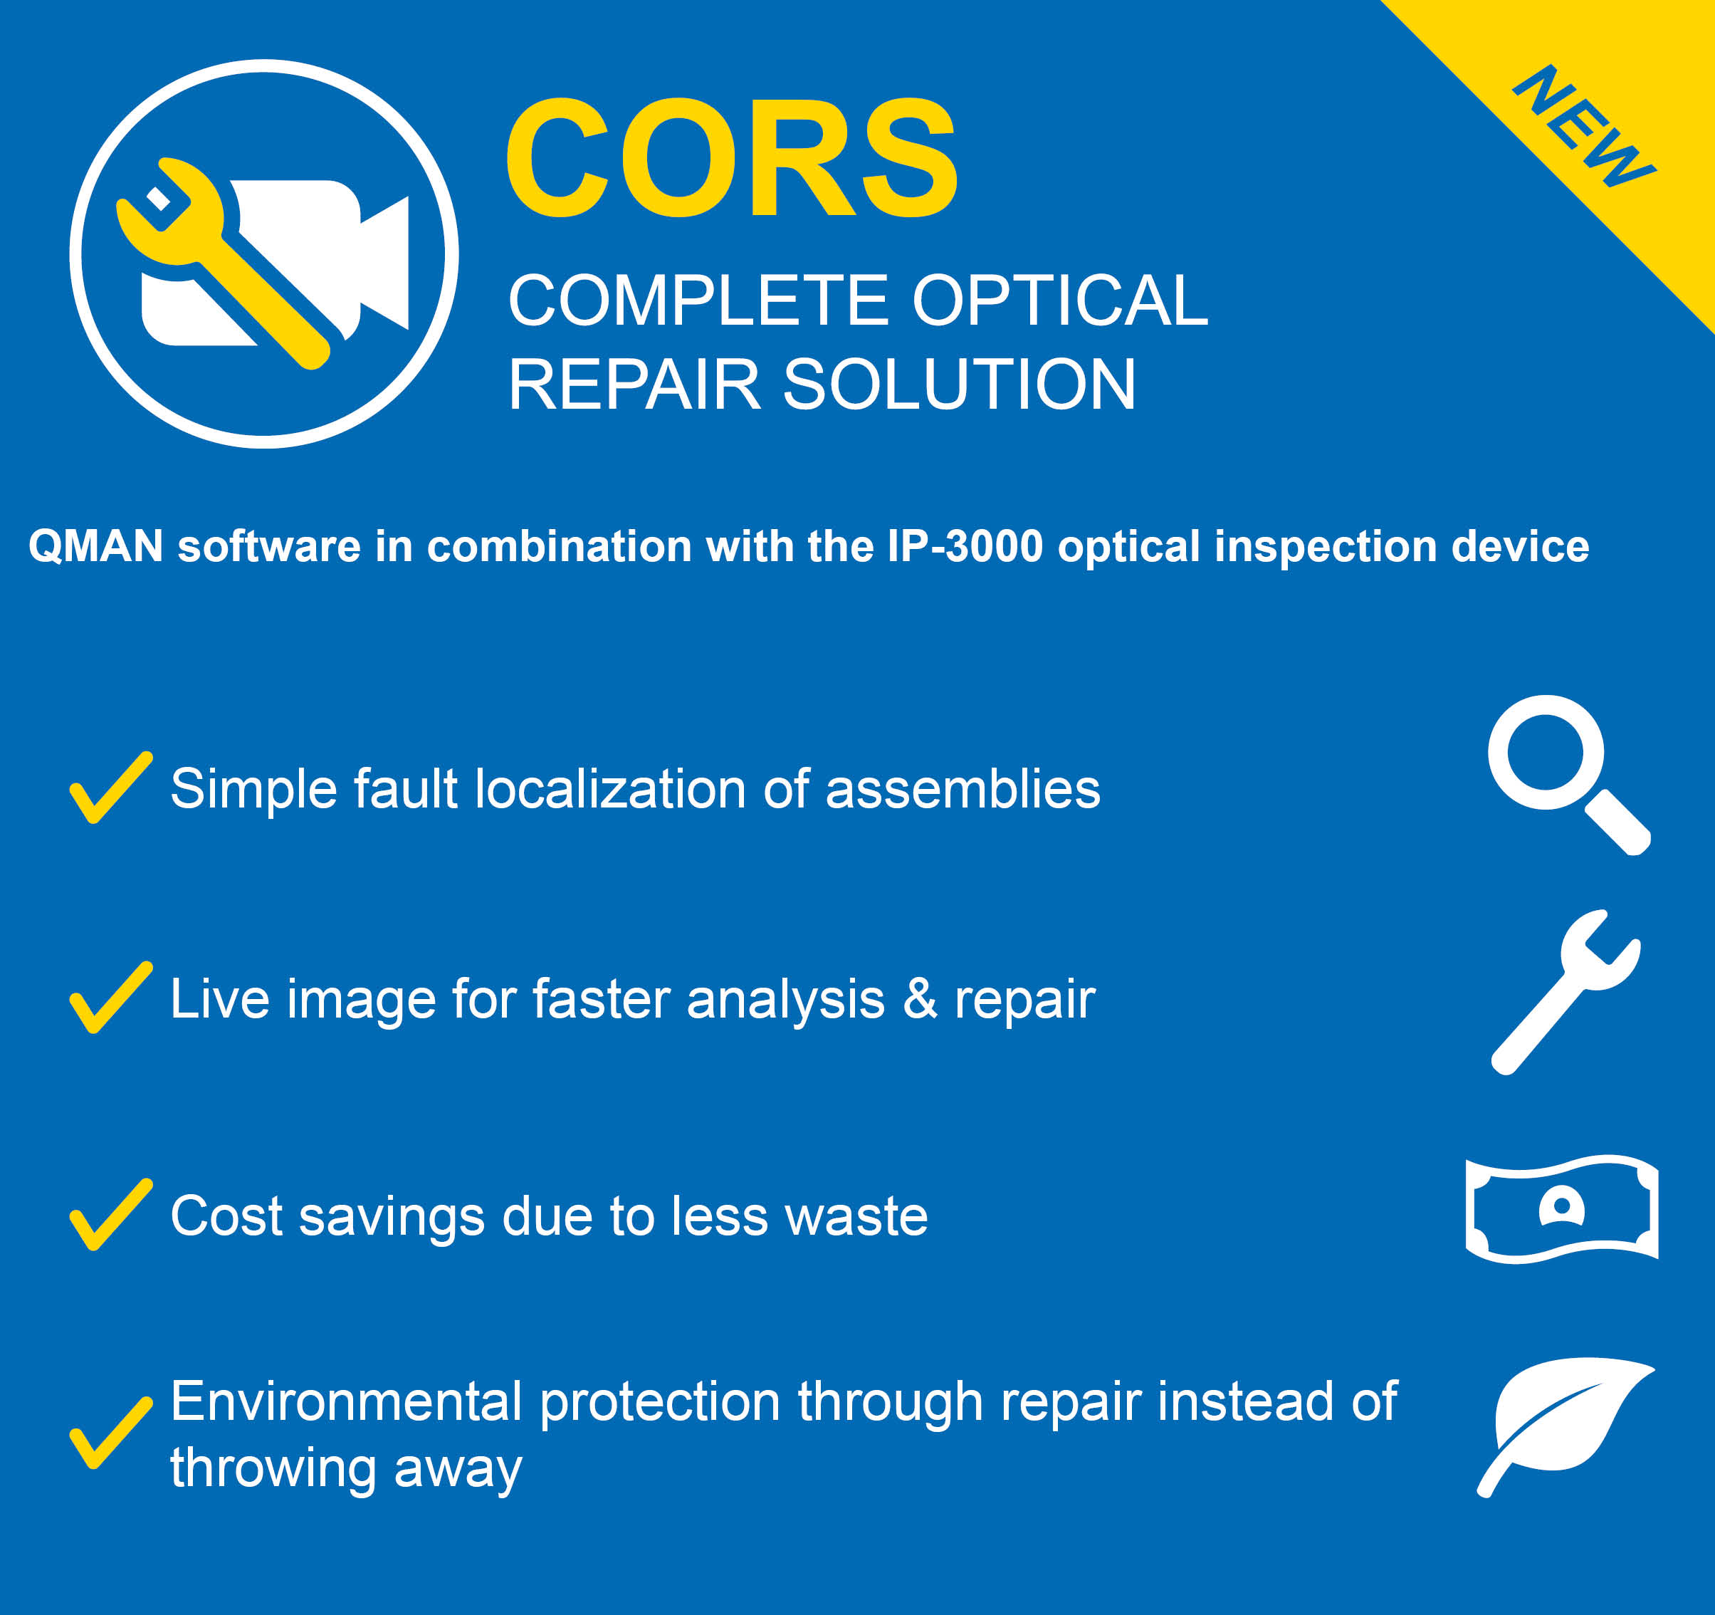

Optical repair solution from Digitaltest locates

assembly defects faster than before

With the Complete Optical Repair Solution (CORS) from Digitaltest
manual search and identification of errors on assemblies will no longer
be necessary in the future, which can save time and money.

The procedure for troubleshooting so far
Manual Visual Inspection (MVI) is an optical test procedure in which the board
is manually inspected for detectable defects using a magnifying glass. The quality
of the inspection depends on the concentration and qualification of the operator and
is therefore highly variable. Particularly as miniaturization progressed and packing
density was high this procedure was and is very time-consuming, which means
that in the case of high quantities, high costs are also incurred.

Digitaltest's solution for the future
Digitaltest has developed with CORS, the Complete Optical Repair Solution,
a special procedure, with which the troubleshooting is no longer as before manual,
but via a fully automated camera system.

The IP-3000 optical inspection system is centrally controlled via the QMAN Repair
Stations software remote controlled and shows the fault location as a live image on
a high-resolution monitor. QMAN imports the test results from different test processes,
which in turn allows a faster analysis. In case of an error, the defective assembly can
then be repaired by QMAN in the shortest possible time.

The solution is in the detail, in the case of CORS, in the camera system of the
IP-3000 inspection system: the side cameras installed there make both solder joint
control and faster detection of short-circuits possible.

The advantages are obvious
With the new remote troubleshooting with Digitaltest's Complete Optical Repair
Solution, assembly faults can be localized, analyzed and repaired faster, which
in turn minimizes the production of rejects and thus protects the environment.

About Digitaltest
As a leading partner in the electronics industry, Digitaltest develops and produces
automated test equipment (ATE) for electronic circuit boards, software for automating production, and quality management systems. Digitaltest is known for innovative solutions
for optimizing the entire manufacturing process – as an interface between CAD, the testing process and production itself. We also offer comprehensive service and support, including complete outsourcing of PCB testing at locations worldwide.

40 years of cutting-edge technology, reliability, and value retention in automated test systems.

For more information contact:
Sarah Boctor-Vauvert
Managing Director/CEO
E-Mail: sarah.boctor-vauvert@digitaltest.de
Phone: +49 7244 96 40 -24
Digitaltest GmbH
Lorenzstr. 3
76297 Stutensee
Germany
www.digitaltest.com

